Weather 2014 Study Guide
* Identify the elements of weather and the instruments used to measure them (e.g., temperature - thermometer; precipitation - rain gauge or Doppler radar; humidity - hygrometer; air pressure - barometer; wind - anemometer; cloud coverage - satellite imaging).
Use this area to write anything down that will help you study:

Sample question:
Which instrument would be used to measure air pressure?
A. thermometer
B. barometer
C. hygrometer
D. anemometer

*Describe conditions that give rise to severe weather phenomena (e.g., thunderstorms, tornados, hurricanes, El Niño/La Niña).
Use this area to write anything down that will help you study:

Sample question:
What creates an El Nino condition?
A. The ocean currents flow in opposite directions along the equator.
B. The shape of the coast changes and fish populations decline.
C. Storms and other weather events in the Atlantic Ocean create it.
D. The prevailing winds do not blow normally near the Pacific Ocean.
*Explain a difference between a low pressure system and a high pressure system, including the weather associated with them.
Use this area to write anything down that will help you study:

Sample Question: What kind of weather can Southern Texas and into Mexico be expecting?
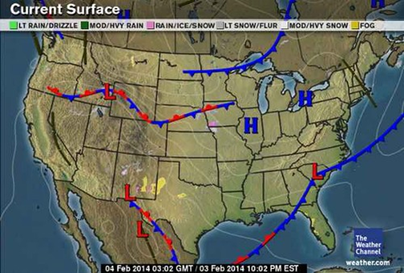
*Diagram and describe cold, warm, occluded, and stationary boundaries (weather fronts) between air masses.
Helpful information: Weather map symbols:
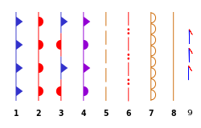 | 1. cold front;  2. warm front;  3. stationary front;  4. occluded front;  5. surface trough;  6. squall/shear line;  7. dry line;  8. tropical wave;  9. trowal
Write a Sample Question:

* Design and conduct a weather investigation, use an appropriate display of the data, and interpret the observations and data.
Sample question:
Students wish to conduct an investigation of the local weather patterns. They collect temperature, air pressure, humidity and wind data for two weeks. How should they display their data for analysis?

A. as a spreadsheet
B. as a graph
C. as a drawing
D. as a verbal explanation

